# Learning Outcome

# After completing this module, the student should be able to understand the Business Analytics

To meet the learning outcome, a student has to complete the following activities

* Use Excel for understanding different types of data (Integer, double, text, date) (5 Hrs)
* Perform operations on different data types. (5Hrs)
* Segregate data in different sheets. (5Hrs)
* Calculate arithmetic mean, geometric mean and Harmonic mean (5Hrs)
* Calculate median from raw & grouped data (5Hrs)
* Calculate mode for row & grouped data (5Hrs)

# Activity 1

## Aim: Use Excel for understanding different types of data (Integer, double, text, date)

## Learning outcome: Able to understand the Business Analytics

**Duration:** 5 Hours

**List of Hardware/Software requirements:**

1. Windows 7/Windows 10
2. MS Office 2010 with Excel or Latest Version

**Code/Program/Procedure (with comments):**

**Integer**

Integer values are written as a sequence of digits, possibly prefixed by a + or - sign. The integer values that can be specified range from -2147483648 to 2147483647. If used where a decimal value was expected, the integer values are automatically converted to decimal values.

**Note**: Hexadecimal values can be used in custom expressions and in calculated columns. They cannot be used when opening data. Hexadecimal-formatted values have a size limitation of 8 characters.

**Examples:**

* 0
* 101
* -32768
* +55
* 0xff = 255
* 0x7fffffff = 2147483647
* 0x80000000 = -2147483648

## INT Excel Function (Integer)

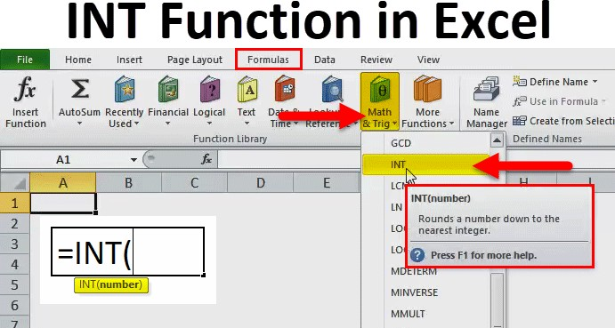

The Microsoft Excel INT Function is a function which is responsible for returning the integer portion of a number. It works by the process of rounding down a decimal number to the integer. The INT Function in Excel is built in Excel function and is categorized as Math & Trig Function in Excel. The INT function in Excel is used either as a worksheet function. Here, negative numbers become more negative because the function rounds down. For example, INT (10.6) returns 10 and INT (-10.6) returns -11.

**Parameters**

* It accepts the following parameters and arguments:
* number – The number to be entered from which you want an integer.

**Return Value**

* The return value will be a numeric integer.

**Procedure to open INT function in MS Excel**

1. You can simply enter the desired Integer excel formula in the required cell to attain a return value on the argument.
2. You can manually open the INT formula in excel dialogue box in the spreadsheet and enter the logical values to attain a return value.
3. Consider the screenshot below to see the INT Function in excel option under the Math & Trig Function menu.

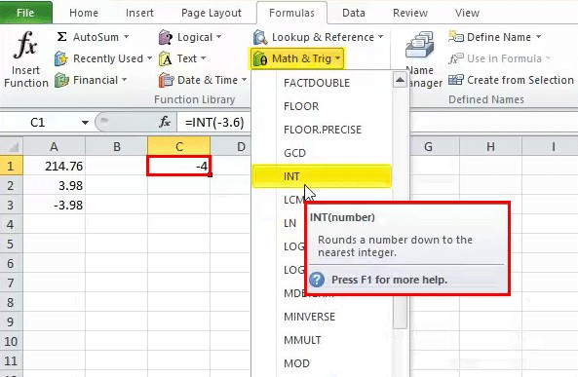

1. Click on the INT function option. The INT formula in excel dialogue box will open where you can put the argument values to obtain a return value.

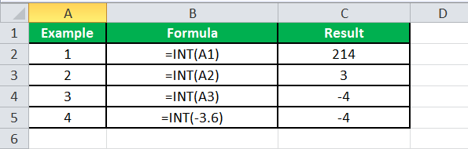

**INT Excel Function Errors**

If you get any kind of error from the INT Excel Function, then it can be any one of the following.

* **#NAME?** – This error occurs when Excel does not recognize the text in the formula. You may have entered a wrong text in the syntax of the function.
* **#VALUE!** – If you enter a wrong type of argument in the syntax of the function, you will be getting this error in Microsoft Excel
* **.#REF!** – Microsoft Excel will display this error if the formula refers to a cell that is not valid.

**Double**

Numeric data type with float precision with double precision in calculations.

**Code:**

Dim x As Integer x = 5.5

MsgBox "value is " & x

**DATE Functions**

* DAY
* MONTH
* YEAR
* TODAY()
* DAYS
* DATE

**DAY Function**

DAY function returns the day number from a valid date. As you know, in Excel, a date is a combination of day, month, and year, DAY function gets the day from the date and ignores the rest of the part.

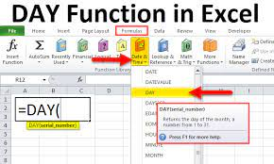

**Syntax**

DAY(serial_number)

**Arguments**

serial_number: A valid serial number of the date from which you want to extract the day number.

**Example**

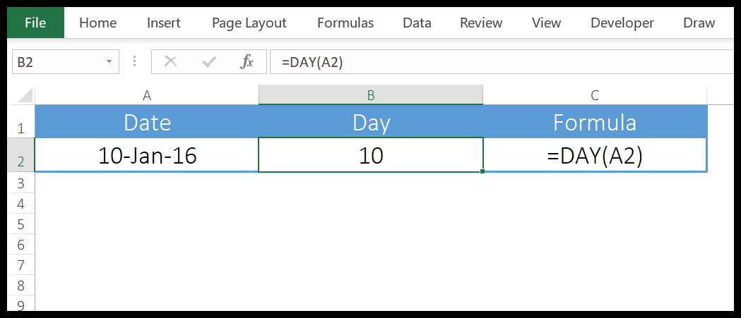

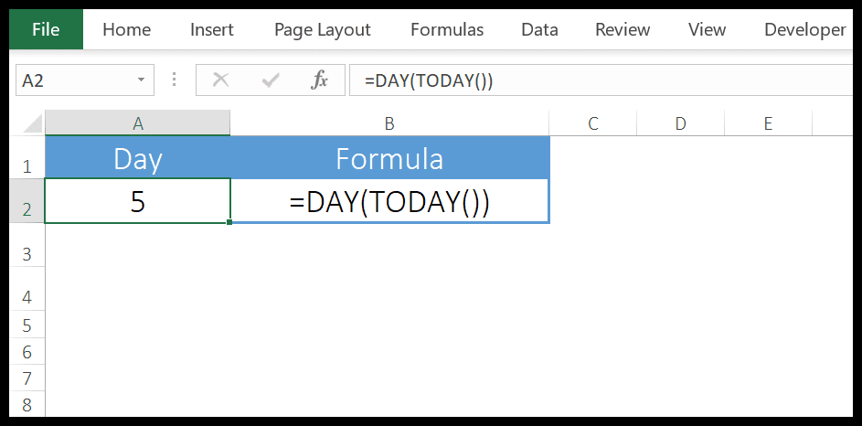

we have used DAY with TODAY to create a dynamic formula that returns the current day number and it will update every time you open your worksheet or when you recalculate your worksheet.

**MONTH Function**

MONTH function returns the month number (ranging from 0 to 12) from a valid date. As you know, in Excel, a date is a combination of day, month, and year, MONTH gets the month from the date and ignores the rest of the part.

**Syntax**

MONTH(serial_number)

**Arguments**

serial_number: A valid date from which you want to get the month number.

**Example**

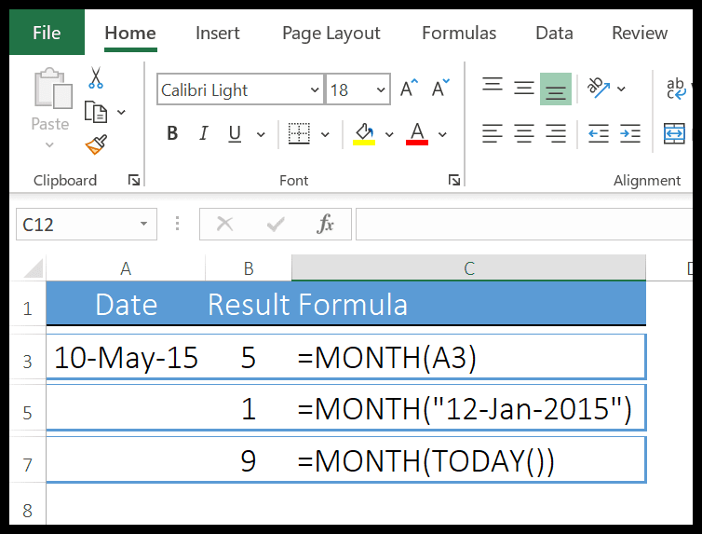

* In the FIRST example, we have simply used date and it has returned the 5 in the result which is the month number of MAY.
* In the SECOND example, we have supplied the date directly in the function.
* In the THIRD example, we have used the TODAY function to get the current date and MONTH has returned the month number from it.

**YEAR Function**

YEAR Function returns the year number from a valid date. As you know, in Excel a date is a combination of day, month, and year, and the YEAR function gets the year from the date and ignores the rest of the part.

**Syntax**

YEAR(date)

**Arguments**

date: A date from which you want to get the year.

**Example**

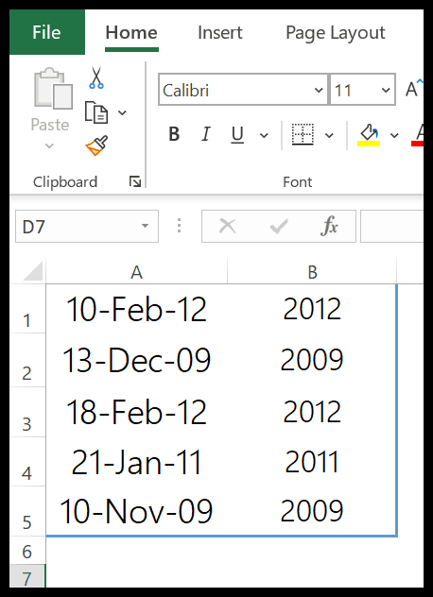

we have used the year function to get the year number from the dates. You can use this function where you have dates in your data and you only need the year number.

**Example(Day,Month,Year)**



**TODAY Function**

The TODAY function returns the current date and time as per the system’s date and time. The date and time returned by the NOW function update continuously whenever you update anything in the worksheet.

**Syntax**

TODAY()

**Arguments**

In the TODAY function, there is no argument, all you need to do is enter it in the cell and hit enter, but be careful as TODAY is a volatile function which updates its value every time you update your worksheet calculations.



We have used TODAY with other functions to get the current month number, current year, and current day.

**DAYS Function**

DAYS function returns the difference between two dates. It takes a start date and an end date and then returns the difference between them in days. This function was introduced in Excel 2013 so not available in prior versions.

**Syntax**

DAYS(end_date,start_date)

**Arguments**

* start_date: It is a valid date from where you want to start the days’ calculation.
* end_date: It is a valid date from where you want to end the days’ calculation.

**Example**

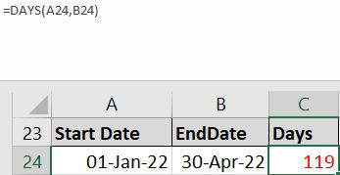

we have referred the cell A24 as the start date and B24 as the end date and we have 119 days in the result.

**DATE Function**

DATE function returns a valid date based on the day, month, and year you input. In simple words, you need to specify all the components of the date and it will create a date out of that.

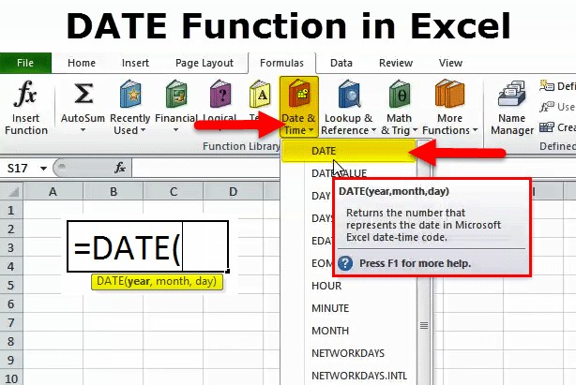**Syntax**

DATE(year,month,day)

**Arguments**

* year: A number to use as the year.
* month: A number to use as the month.
* day: A number to use as a day.

**Example**

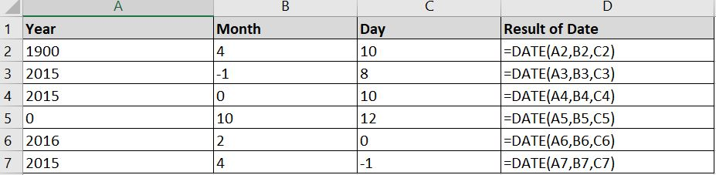

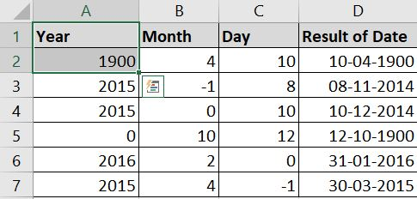

**TEXT Function**

TEXT in Excel is used to convert a numeric value to a text string in a specific format.

The syntax for the Excel TEXT function is as follows:

TEXT(value, format_text)

Where:

* Value - the numeric value to be converted to text. It can be a number, date, reference to a cell containing a numeric value or another function that returns a number or date.
* Format_text - the format that you want to apply. It is supplied in the form of a format code enclosed in the quotation marks, e.g. "mm/dd/yy".

Generally, an Excel TEXT formula is used in the following situations:

* To display numbers in a more readable way or in a format that makes more sense for your users.
* To display dates in a specific format.
* To combine numbers or dates with certain text or characters.

For example, if you want to pull the date from cell A2 and show it in another cell in the traditional date format like "January 1, 2016", you use the following Excel TEXT formula:

=TEXT(A2, "mmmm d, yyyy")

**Example**

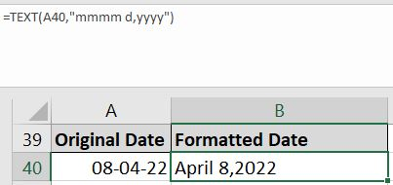

**Output/Results snippet:**

**INT**



**Double**

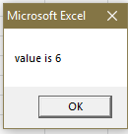

**DATE Functions**







**TEXT**



**References:**

* <https://excelhub.org/how-to-use-excel-int-function/>

# 

# Activity 2

## Aim: Perform operations on different data types.

## Learning outcome: Able to understand the Business Analytics

**Duration:** 5 Hours

**List of Hardware/Software requirements:**

1. Windows 7/Windows 10
2. MS Office 2010 with Excel or Latest Version
3. VBA Developer

**Code/Program/Procedure (with comments):**

* Step 1 − First, enable the 'Developer' menu in Excel 20XX. To do the same, click File → Options.
* Step 2 − Click ‘Customize the Ribbon’ tab and check 'Developer'. Click 'OK'.

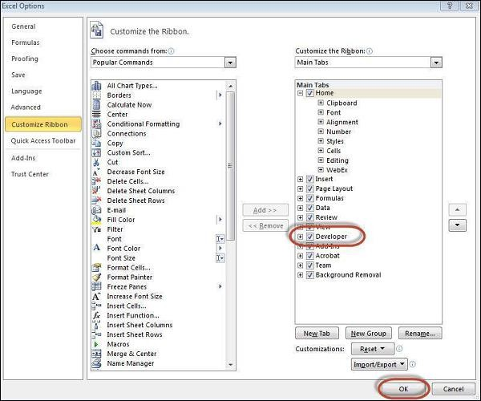

* Step 3 − The 'Developer' ribbon appears in the menu bar

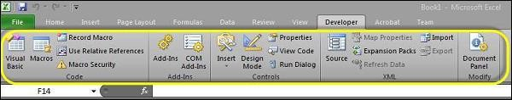

* Step 4 − Click the 'Visual Basic' button to open the VBA Editor.

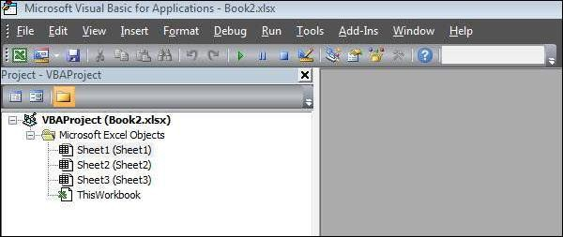

**Datatypes in Excel**

## Code

## Private Sub cmdCalculate_Click()

Dim number1, number2, number3 As Single

‘Declare Variables

Dim total, average As Double

number1 = Cells(1, 1).Value

number2 = Cells(2, 1).Value

number3 = Cells(3, 1).Value ‘

Total of 3 Values

total = number1 + number2 + number3 average = total / 3

‘Display Total

Cells(5, 1) = "Total:-" & total ‘Display Average

Cells(6, 1) = "Average:-" & average

## End Sub

**Code**

## Private Sub cmdConcatenate_Click()

‘Declare the String Variables Dim firstName As String

Dim lastName As String

Dim yourName As String

firstName = Cells(1, 1).Value

lastName = Cells(2, 1).Value

‘Concatenate with firstName and lastName

yourName = firstName + " " + lastName ‘Result of fullName

Cells(3, 1) = yourName

## End Sub

**Output/Results snippet:**

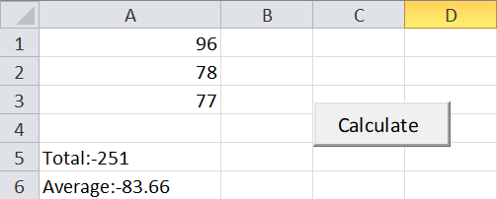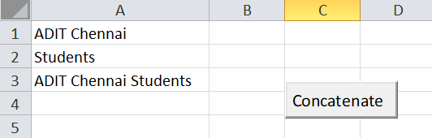

## References:

* <https://www.automateexcel.com/vba/data-types-variables-constants/>

# Activity 3

## Aim: Segregate data in different sheets.

## Learning outcome: Able to understand the Business Analytics

**Duration:** 5 Hours

**List of Hardware/Software requirements:**

1. Windows 7/Windows 10
2. MS Office 2010 with Excel or Latest Version
3. VBA Developer

**Code/Program/Procedure (with comments):**

1. Open Excel File and press “Alt+F11”

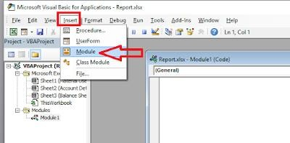

1. Click on “Insert” than click on “Module

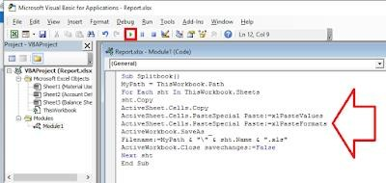

## Code

**Sub Splitbook()**

MyPath = ThisWorkbook.Path

For Each sht In ThisWorkbook.Sheets

‘Copy of the Sheet

sht.Copy ActiveSheet.Cells.Copy

ActiveSheet.Cells.PasteSpecial Paste:=xlPasteValues ActiveSheet.Cells.PasteSpecial Paste:=xlPasteFormats

‘Save the Sheet Data

ActiveWorkbook.SaveAs _

Filename: =MyPath & "\" & sht.Name & ".xls"

ActiveWorkbook.Close savechanges:=False

Next sht

## End Sub

Click on “Run” icon

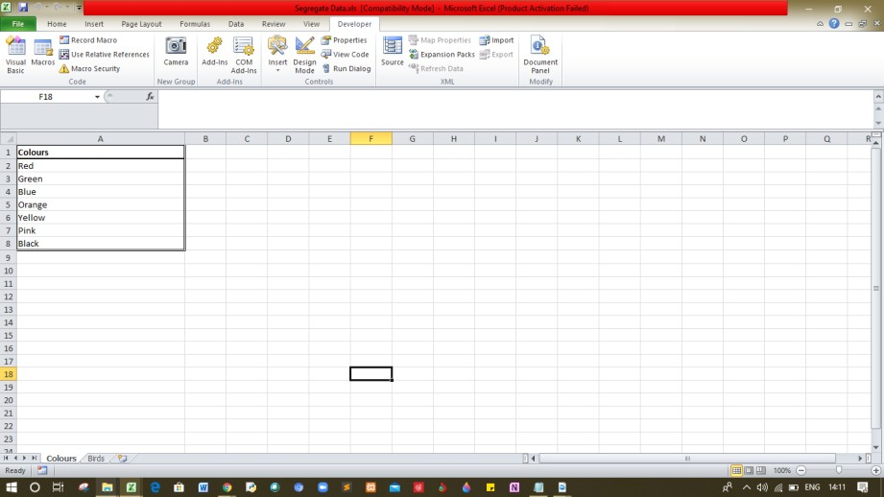

## Output/Results snippet:

That’s it your each worksheet will be converted into separate excel file

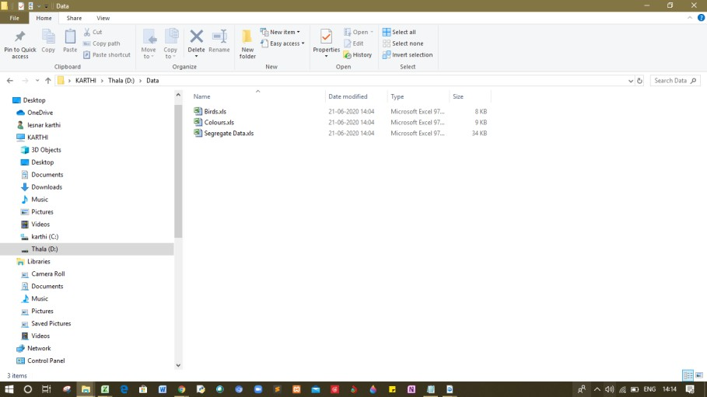

## References:

* <http://www.bsocialshine.com/2017/08/how-to-split-each-excel-sheet-into.html>

# Activity 4

## Aim: Calculate arithmetic mean, geometric mean and Harmonic mean (5Hrs)

## Learning outcome: Able to understand the Business Analytics

**Duration:** 5 Hours

**List of Hardware/Software requirements:**

1. Windows 7/Windows 10
2. MS Office 2010 with Excel or Latest Version

## Code/Program/Procedure (with comments):

**Arithmetic Mean on Excel**

Arithmetic Mean, commonly used term in statistics, is the average of the numerical values set and is calculated by firstly calculating the sum of number in the set and then dividing resultant by count of those numbers.

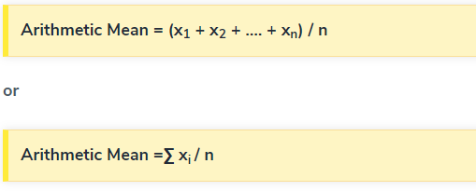**Arithmetic Mean formula on Excel**

Where,

x1, x2, x3, xn are the observations

n is the number of observations

Alternatively, it can be symbolically written as shown below-



In the above Equation, the symbol ∑ is known as sigma. It implies the summation of the values

**Example**

There are five observations. These are 56, 44, 20, 50, 80. Find their arithmetic mean.

Solution

Here, the observations are 56, 44, 20, 50, 80.

n = 5

Therefore, the calculation is as follows,

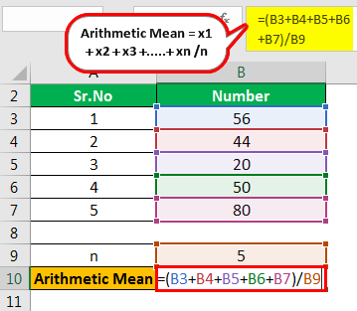

=56+44+20+50+80/5

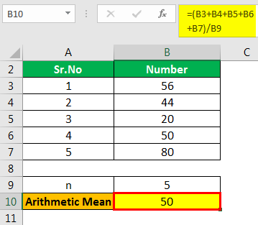

Arithmetic Mean=**50**

**The GEOMEAN function**

In mathematics, the geometric mean is a mean or average, which indicates the central tendency or typical value of a set of numbers by using the product of their values (as opposed to the arithmetic mean which uses their sum).  The geometric mean is defined as the **n**th root of the product of **n** numbers, *i.e.* for a set of numbers **x1**, **x2**, ..., **xn**, the geometric mean is defined as

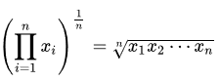

In two dimensions, it is the equivalent of finding the equivalent square with the same area as the rectangle given by the two dimensions cited:

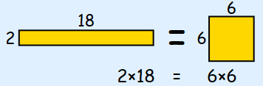

In three dimensions, it is the equivalent of finding the equivalent cube with the same volume as the given hexahedron with the three dimensions cited:

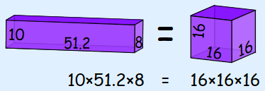

The idea continues in **n**dimensions.

The Excel function **GEOMEAN**returns the geometric mean of an array or range of positive data.  For example, you can use **GEOMEAN** to calculate average growth rate given compound interest with variable rates.  It has the following syntax:

**GEOMEAN(number1, [number2], ...)**

The **GEOMEAN** function has the following arguments:

* **number1**, **number2**,...where **number1** is required, and subsequent numbers are optional.  There can be between one (1) and 255 numbers. You can also use a single array or a reference to an array instead of arguments separated by commas.

It should be further noted that:

* arguments can either be numbers or names, arrays, or references that contain numbers
* logical values and text representations of numbers that you type directly into the list of arguments are counted
* of an array or reference argument contains text, logical values or empty cells, those values are ignored; however, cells with the value zero are included
* arguments that are error values or text that cannot be translated into numbers cause errors
* if any data point ≤ 0, **GEOMEAN** returns the *#NUM!* error value
* the equation for the geometric mean is:



**Example**

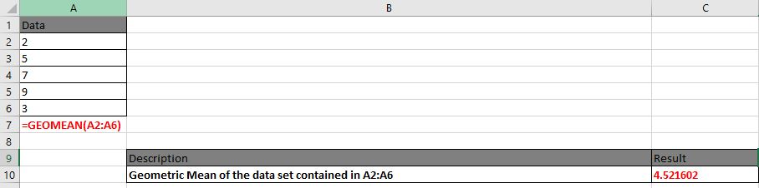

**Harmonic mean on Excel**

The Excel HARMEAN function returns the harmonic mean for a set of numeric values. The harmonic mean is the reciprocal of the arithmetic mean of reciprocals. Harmonic mean can be used to calculate a mean that reduces the impact of outliers.

## Harmonic mean Formula on Excel



=HARMEAN (number1, [number2], ...)

* number1 - First value or reference.
* number2 - [optional] Second value or reference. Where:

X1, X2,…Xn – Data Points

n – Total number of data points

**When to use harmonic mean?**

This average is used when data values are expressed in relative units, e.g. speed unit (miles/ h) or salary per hour of work (USD / h).

The use of the harmonic mean gives equal weight to each data. Using the arithmetic mean in this case would give more weight to the higher-valued data, and thus the mean would be overstated.

**Example**

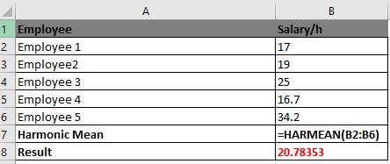

## Output/Results

## Arithmetic mean



**Geometric Mean**



**Harmonic Mean**



## References:

* https:/[/www.educba.com/arithmetic](http://www.educba.com/arithmetic-mean-formula/)-[mean-formula/](http://www.educba.com/arithmetic-mean-formula/)
* https:/[/www.e](http://www.exceltip.com/statistical-formulas/excel-geomean-function.html)x[celtip.com/statistical-formulas/excel-geomean-function.html](http://www.exceltip.com/statistical-formulas/excel-geomean-function.html)
* https:/[/www.educba.com/harmoni](http://www.educba.com/harmonic-mean-formula/)c[-mean-formula/](http://www.educba.com/harmonic-mean-formula/)

# Activity 5

## Aim: Calculate median from raw & grouped data

## Learning outcome: Able to understand the Business Analytics

**Duration:** 5 Hours

**List of Hardware/Software requirements:**

1. Windows 7/Windows 10
2. MS Office 2010 with Excel or Latest Version

## Code/Program/Procedure (with comments):

## Median Function in Excel

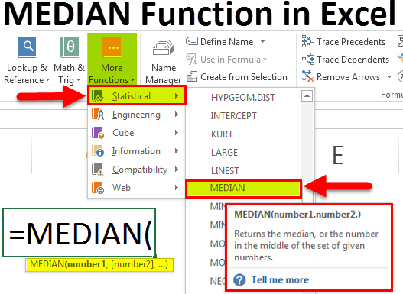

1. Number 1 (required argument) – The number arguments are a set of single or more numeric values (or arrays of numeric values), for which you want to calculate the median.
2. Number 2 (optional argument)

Median is a function which is used to find the middle number in each range of numbers. When you are finding median manually, you need to sort the data in ascending order but in Excel, you can simply use the Median function and select the range and you will find your median. We take the same example as above to find the median of marks obtained by students. So, we use

=MEDIAN (B2: B12).

## Output/Results snippet:

**Median**

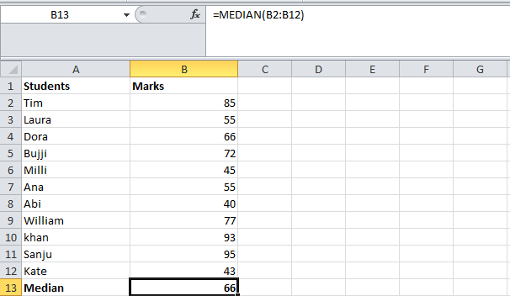

## References:

* https:/[/www.educba.com/ex](http://www.educba.com/excel-median-function/)c[el-median-function/](http://www.educba.com/excel-median-function/)

# Activity 6

## Aim: Calculate mode for row & grouped data

## Learning outcome: Able to understand the Business Analytics

**Duration:** 5 Hours

**List of Hardware/Software requirements:**

1. Windows 7/Windows 10
2. MS Office 2010 with Excel or Latest Version

## Code/Program/Procedure (with comments):

**MODE in Excel**

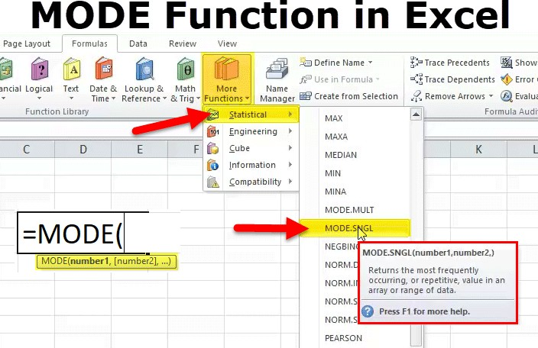

1. number1 (compulsory OR required argument) – Arrays of cell reference or numeric values (set of one or more numeric values) for which we have to calculate the mode.
2. number2 (Optional OR not required) – Arrays of cell reference or numeric values (set of one or more numeric values) for which we have to calculate the mode.

Mode helps you to find out the value that occurs the most number of times. When you are working on a large amount of data, this function can be a lot of help. To find the most occurring value in Excel, use the MODE function and select the range you want to find the mode of. In our example below, we use =MODE (B2: B12) and since 2 students have scored 55, we get the answer as 55.

## Output/Results snippet:

## Mode

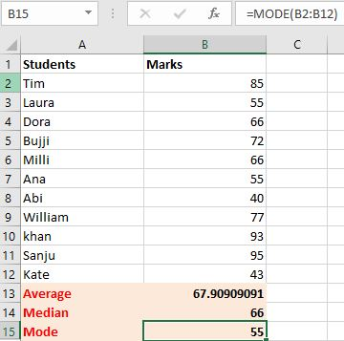

## References:

* https:/[/www.educba.com/mode](http://www.educba.com/mode-in-excel/)-[in-excel/](http://www.educba.com/mode-in-excel/)